2023 Rotary Chilly Chili Cookoff Registration Form

Name of restaurant: _______________________________________________________________________

Mailing address for restaurant: ______________________________________________________________
Contact person(s) from the restaurant for this event: ____________________________________________

Contact person(s) cell phone number: __________________________________________________________

Contact person(s) email address: ______________________________________________________________

Name of non-profit (partnering with restaurant): ______________________________________________
There is no registration fee for this event.
I understand that by signing this form, I have an obligation to bring 5 gallons of chili, a heating source (NO GAS), and a ladle to this event to serve chili from 11:00 am – 2 pm, or until the chili runs out. I understand that setup is at 9:00 am and it’s up to me to bring materials to promote my restaurant/non-profit. I understand that this event exists to promote my restaurant/ non-profit and collect donations from the public for my non-profit. I understand that this event will be more successful if I encourage my database of patrons and volunteers to attend this event and support us.
Signed: _______________________________________________________
Date: ______________________
REGISTRATION DUE BY Tuesday, January 3rd, 2023.
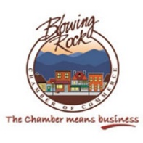
Submit to John Goheen at Blowing Rock Chamber of Commerce
132 Park Ave. / P.O. Box 406, Blowing Rock
john@blowingrock.com -- (828) 295-7851

