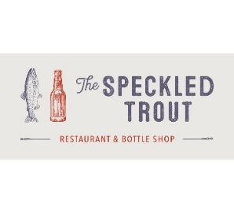

Sponsored by The Speckled Trout

2023 Beer Garden Vendor Information Form
On Saturday, January 28th, the annual Beer Garden for the Blowing Rock WinterFest will be hosted at Meadowbrook Inn in the Highland Room. We are revamping this event with some exciting new additions that will drive traffic and create a true festival atmosphere, and we would love to have your participation. The event offers a unique opportunity to promote your business to both new and current customers, with both locals and visitors attending. Below are details of this event:
Event Date: Saturday, January 28, 2023
Location: Meadowbrook Inn, Highland Room (711 Main St, Blowing Rock, NC 28605)
Beer Garden Event Time: 1:00pm-3:00pm *Please be READY by 12:30pm. If you are not here and set up by this time, your table will be removed, and your spot will be forfeited.
Set Up Details
- Set up begins at 11:30am. Please limit your unloading time to 20 minutes to assure all the vendors will be ready by the 1:00 pm service time.
- If needed, each vendor can be provided with a table and/or slim bar back table for serving. The Chamber will also acquire all necessary ABC Permits.
- Please prepare to serve 300+ people between 1-3:00 pm.
- Please use the lobby entrance of the Meadowbrook Inn where you can use the stairs or the elevator to reach the Highland Room (events will be going on and blocking other entrances).
- Please bring any signage and promotional materials (menus, coupons, rack cards) that you are welcome to hand out to guests. Decorating tables is highly encouraged!
- No signage will be allowed to hang on the walls. All signage will have to be placed on tables or be free standing.
- Any sales of merchandise such as shirts, hoodies, and hats are encouraged. Each business is responsible for their own POS system or cash transactions. WiFi is available at this venue.
- If selling any canned/ bottled inventory, an off-premises sales license must be provided.
- The Chamber will provide a taster glass to the attendees.
- Each participating business will be provided with their own designated parking spot.
- Booth registration deadline is Monday, January 14th.

Please contact John Goheen with any questions, and complete the attached form to reserve your space! 828-295-7851 or John@blowingrock.com

