Dear Area Restaurant Owners/Chefs:
Thursday, January 26th will be the kickoff to Blowing Rock WinterFest with our popular local restaurant showcase, WinterFeast! We would love to have your participation in this event. It offers a unique opportunity to promote your restaurant to new guests and reacquaint yourself with past customers. Below are details of this event:
Event Date: Thursday, January 26th, 2023
1st Seating 5:30pm -6:30pm (120 people)
2nd Seating 7:00pm – 8:00pm (120 people)
Location: Green Park Inn
Start of event: 5:30pm *Please be READY by 5pm. If you are not here and set up by this time, your table will be removed and your spot will be forfeited. Chamber staff will be conducting table inspections at 5pm.
- Set up begins at 3pm. Please limit your unloading time to 10 minutes to assure all the restaurants will be ready by the 5pm service time.
- Each restaurant will be provided with one 6-foot table for serving and one slim line table behind for staging, along with the linens for each.
- The first seating is at 5:30pm. This event uses cruise-style. The second seating will be at 7pm.
- Please prepare for 300 people. This event has sold out for the past several years!
- Please bring signage and promotional materials (menus, coupons, rack cards) to hand out to guests. Decorating tables is highly encouraged!
- You will need to bring all serving utensils, chaffing dishes and serving platters you need to serve your food and keep it hot or cold.
- The cash bar is open all night.
- Table registration deadline is Tuesday, January 3rd and is first come, first served.
Please contact me with any questions and complete the attached form to reserve your space!
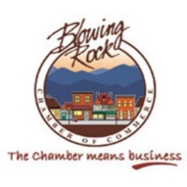
John Goheen
828-295-7851
John@blowingrock.com

